**Creation of VM from Terraform as infrastructure as code**

1. Now type “az login” and copy the link generated and the code by the command

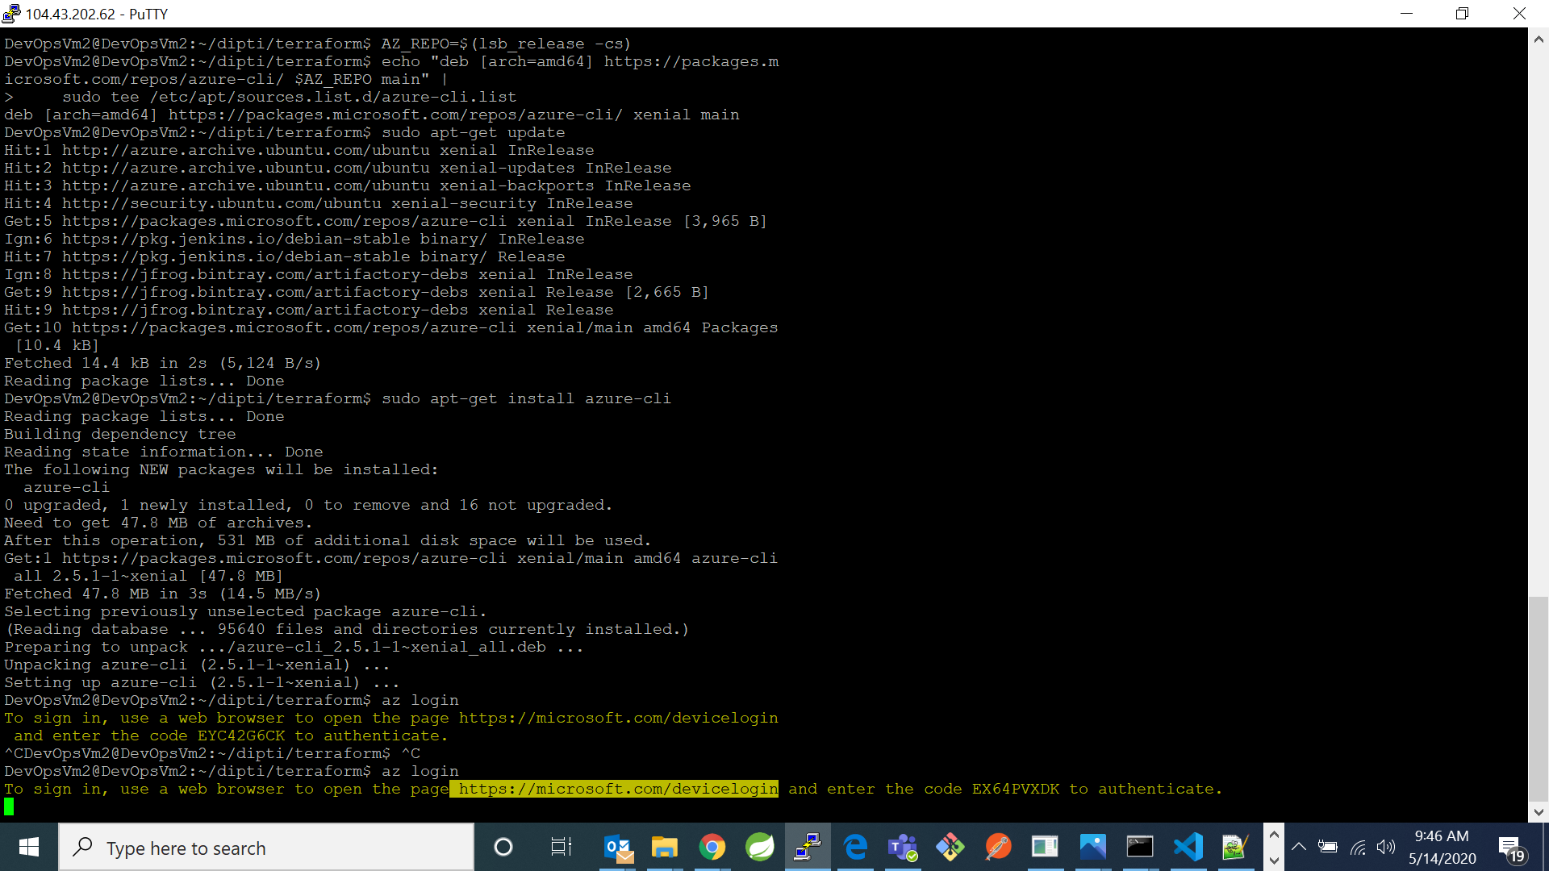

1. Go to browser and copy the url. It will open a page which will be asking to enter a code. Copy the code generated by the “az login” command here and click next. It will take you to choose an account.

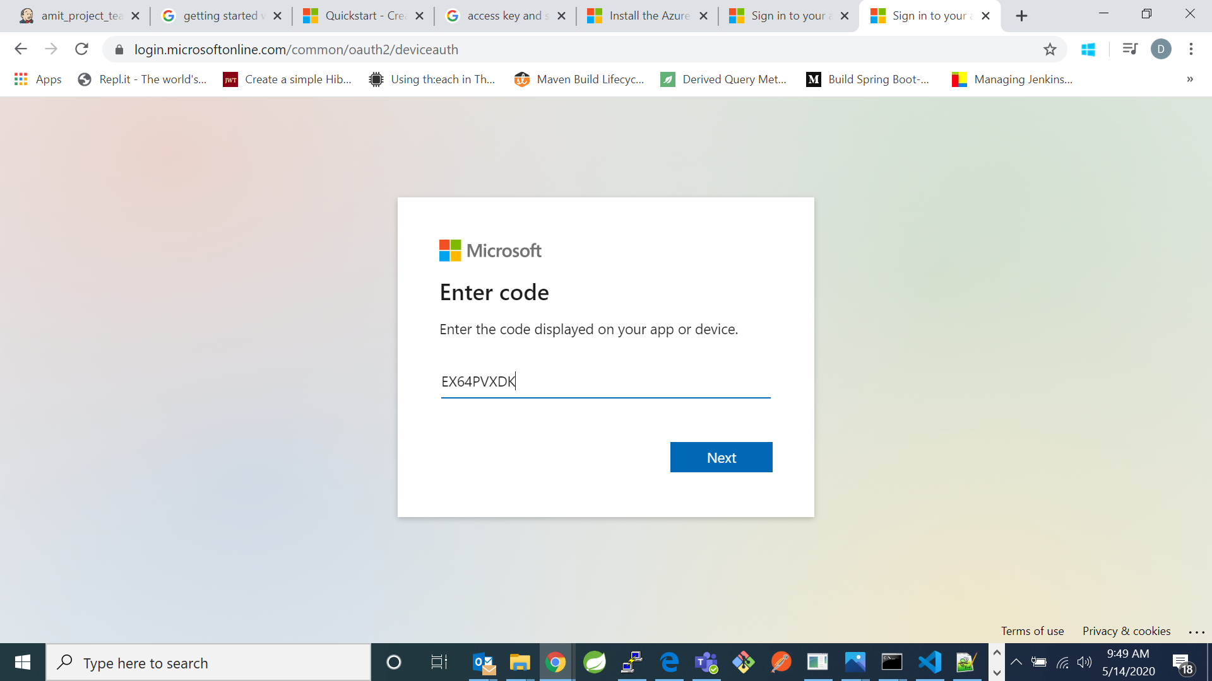

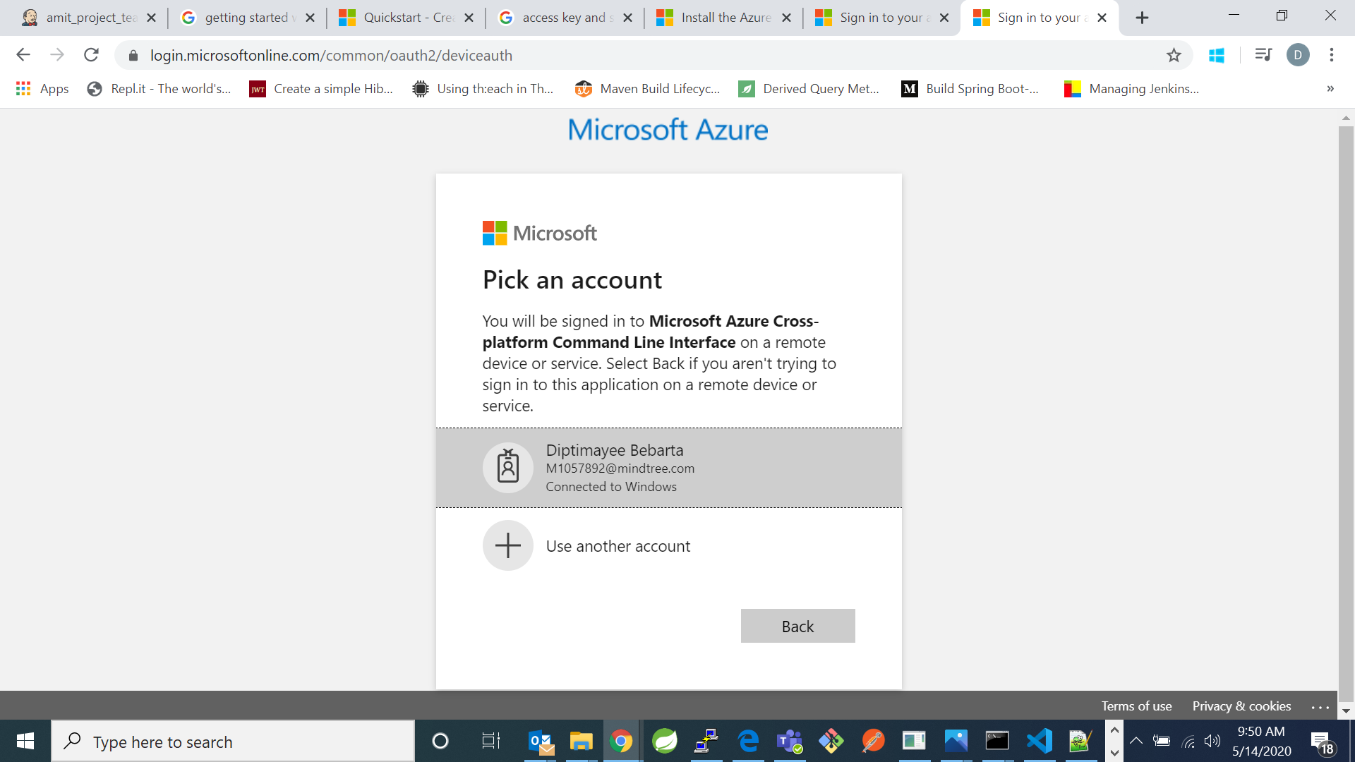

1. After signing in it will show the message:



1. Now go back to your linux cli, it will show the details of your account and session:

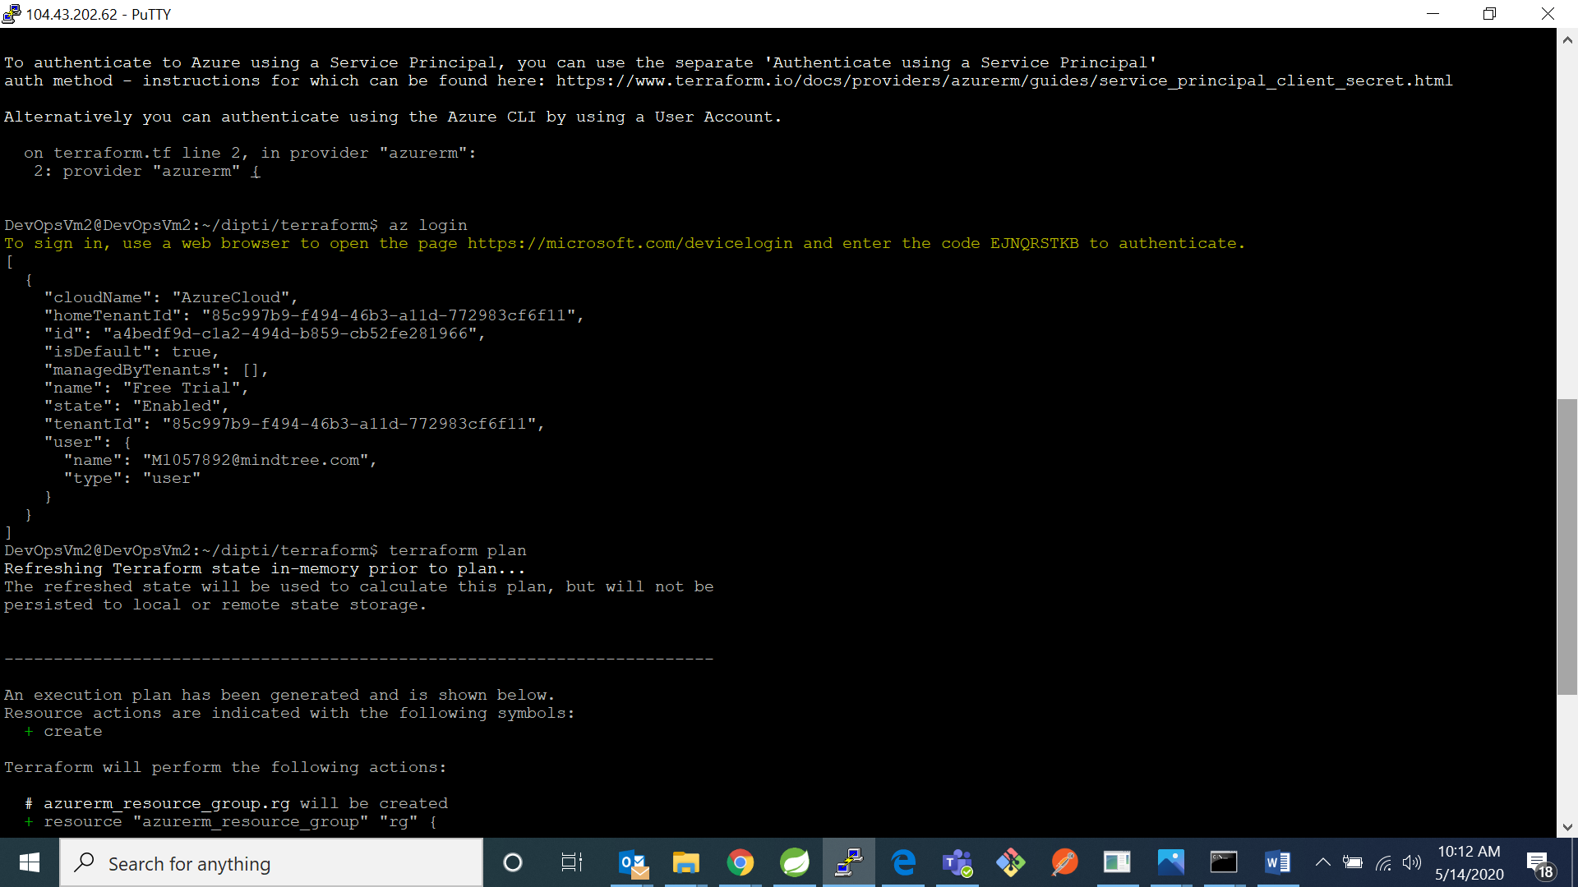

Configuration in terraform for creation of vm

1. Create your own directory for terraform using command “mkdir terraform”

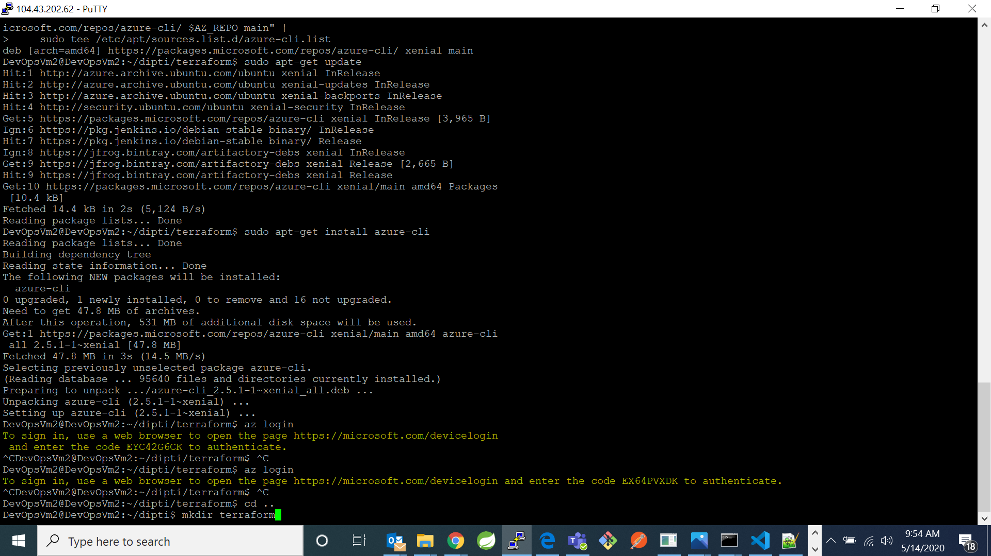

1. Now go the directory

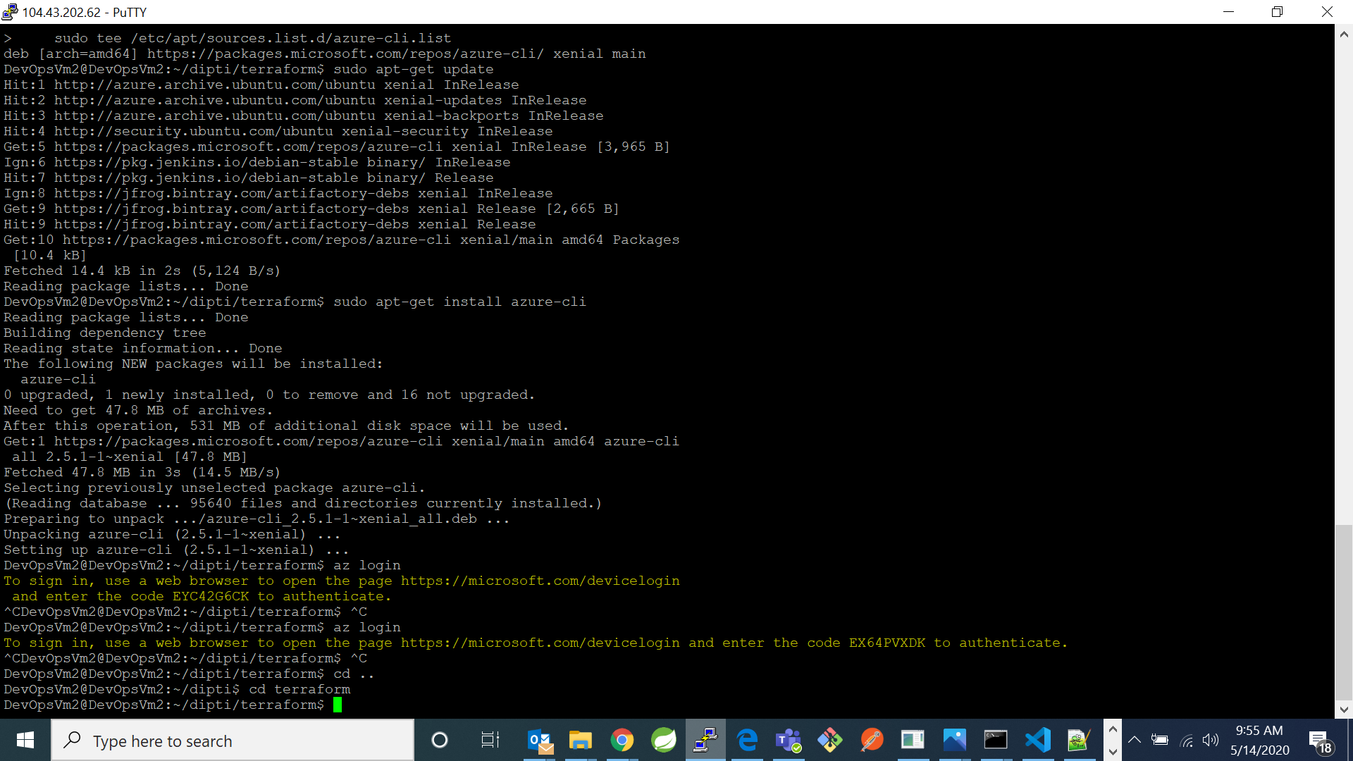

1. Now type command “sudo nano terraform.tf”. And write the following code in that file:

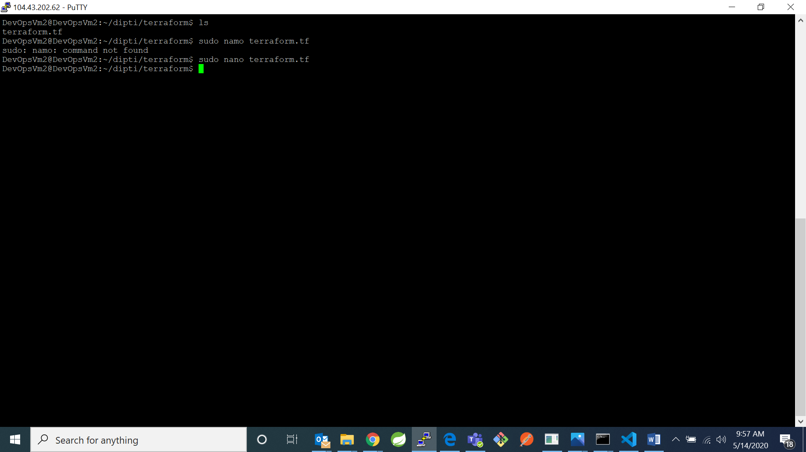

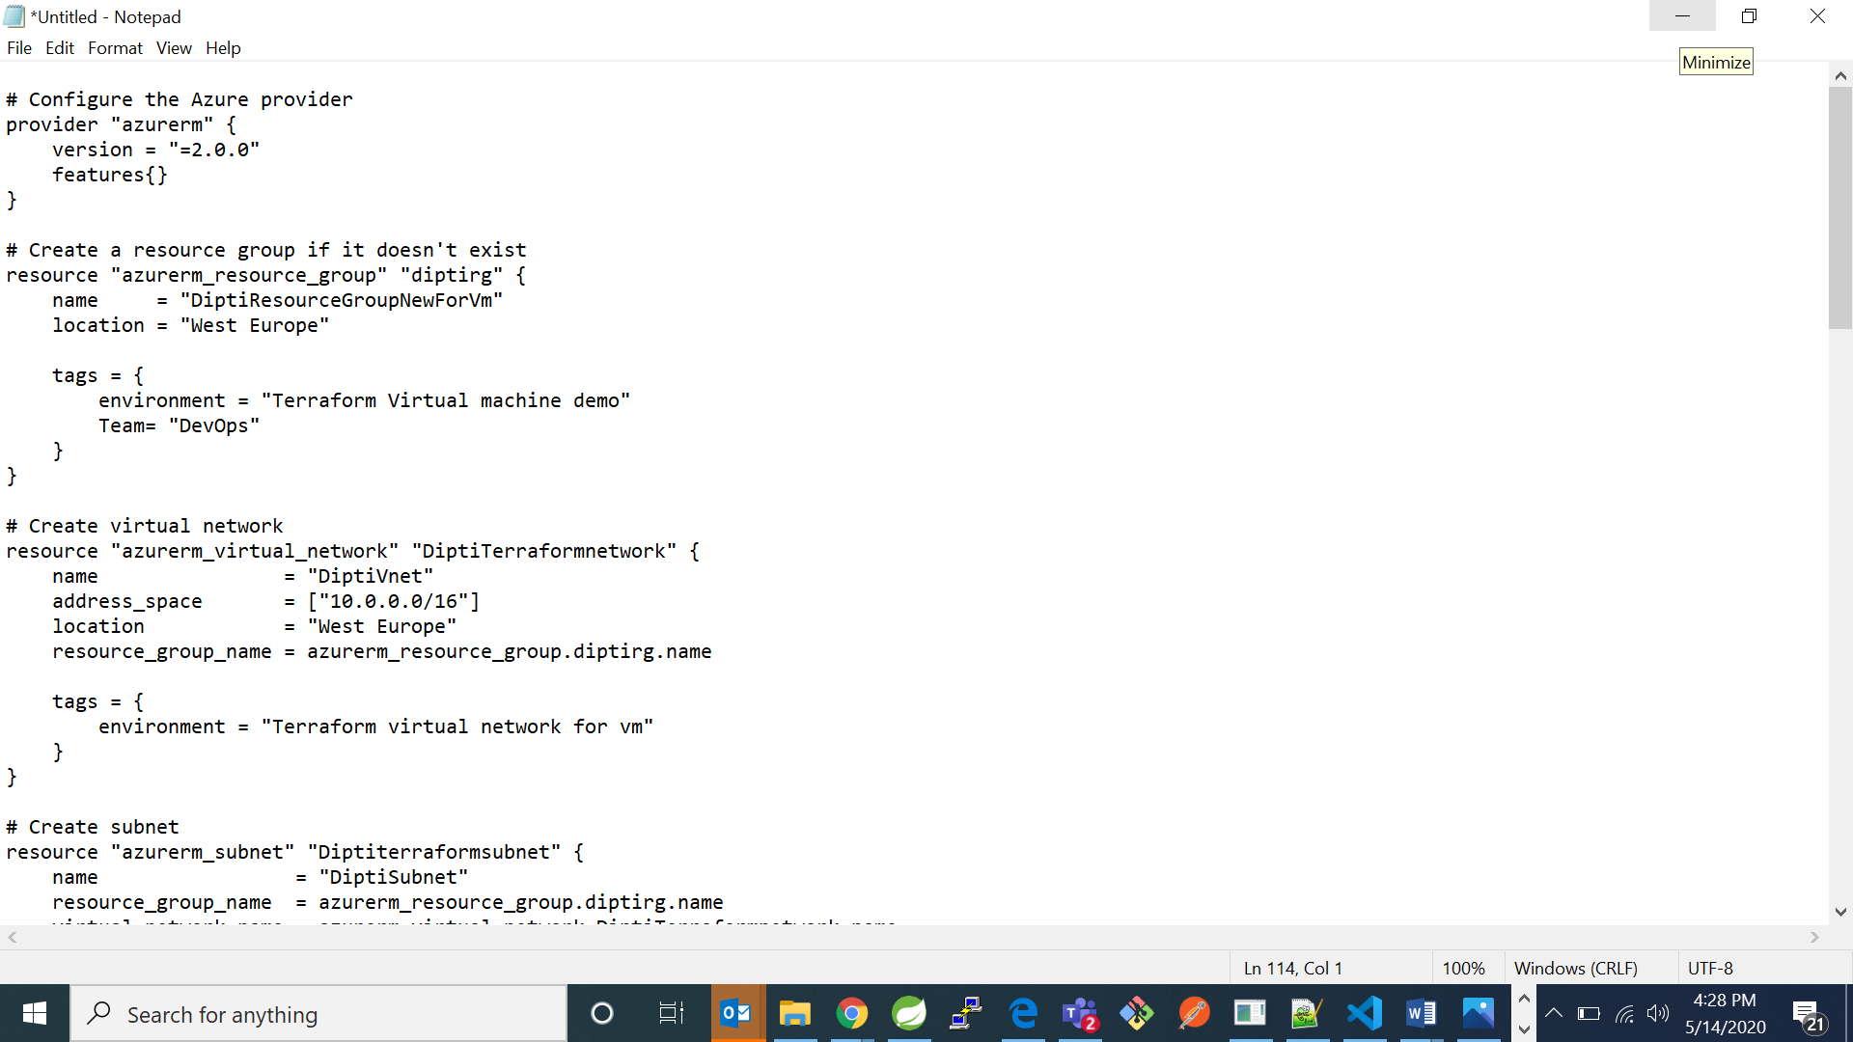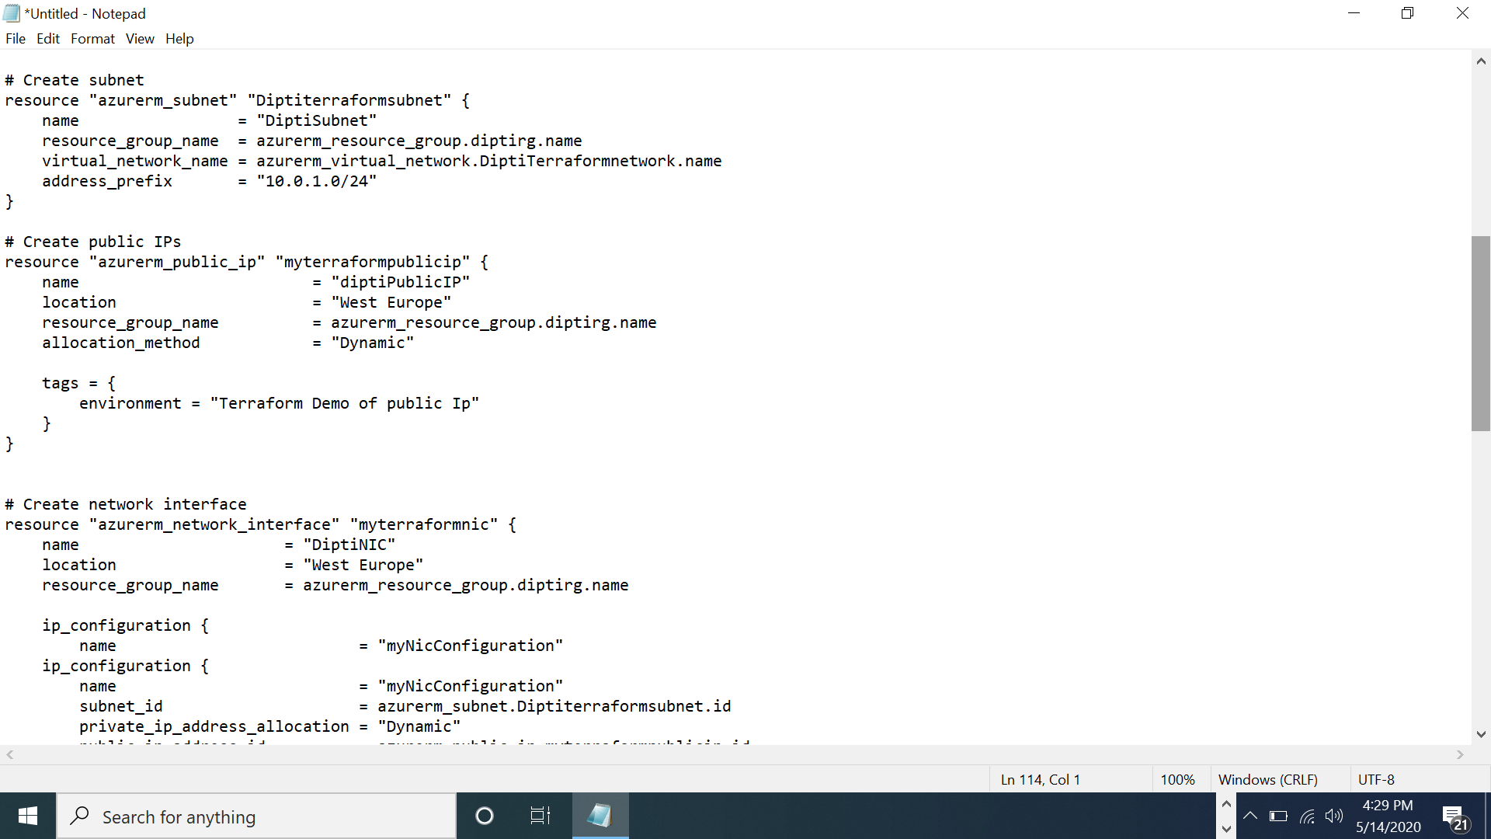

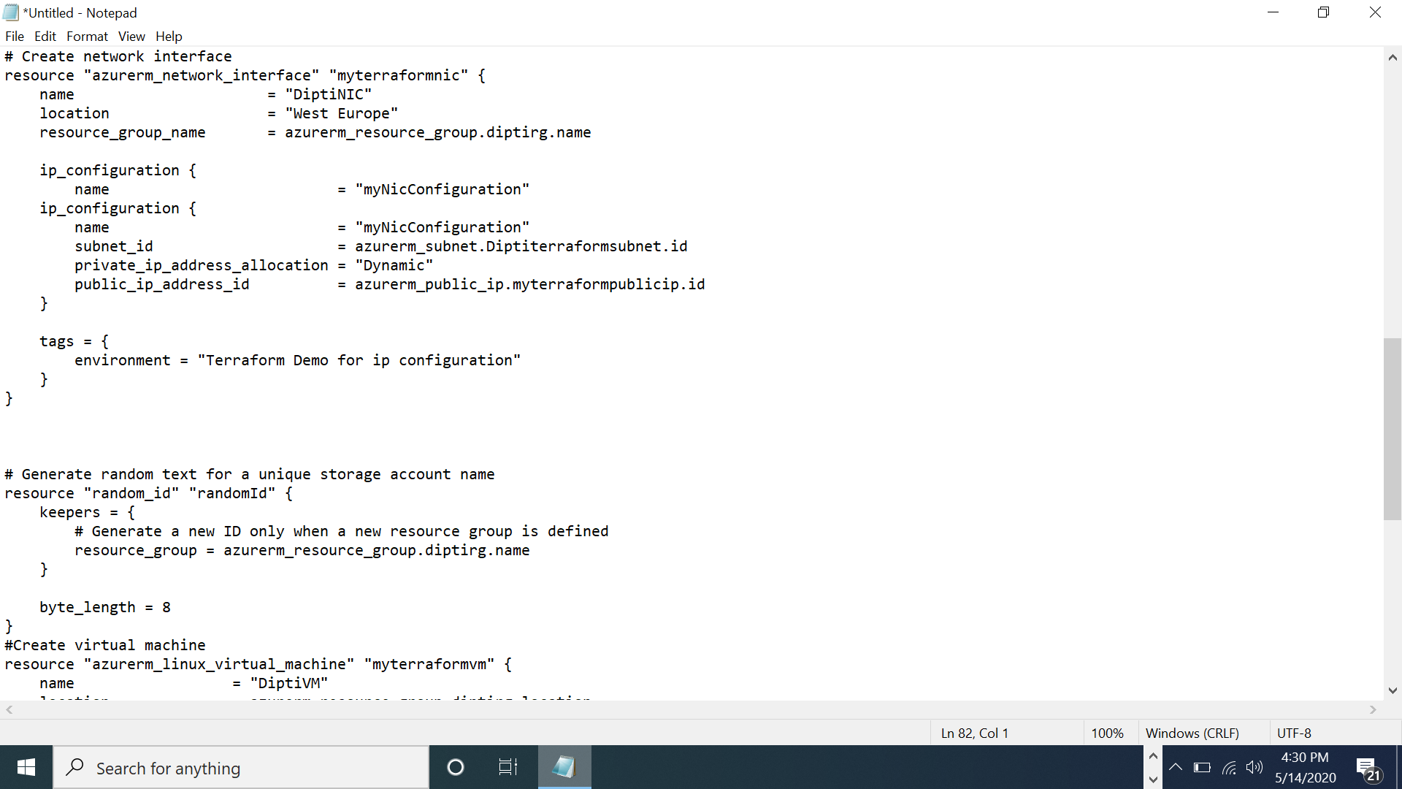

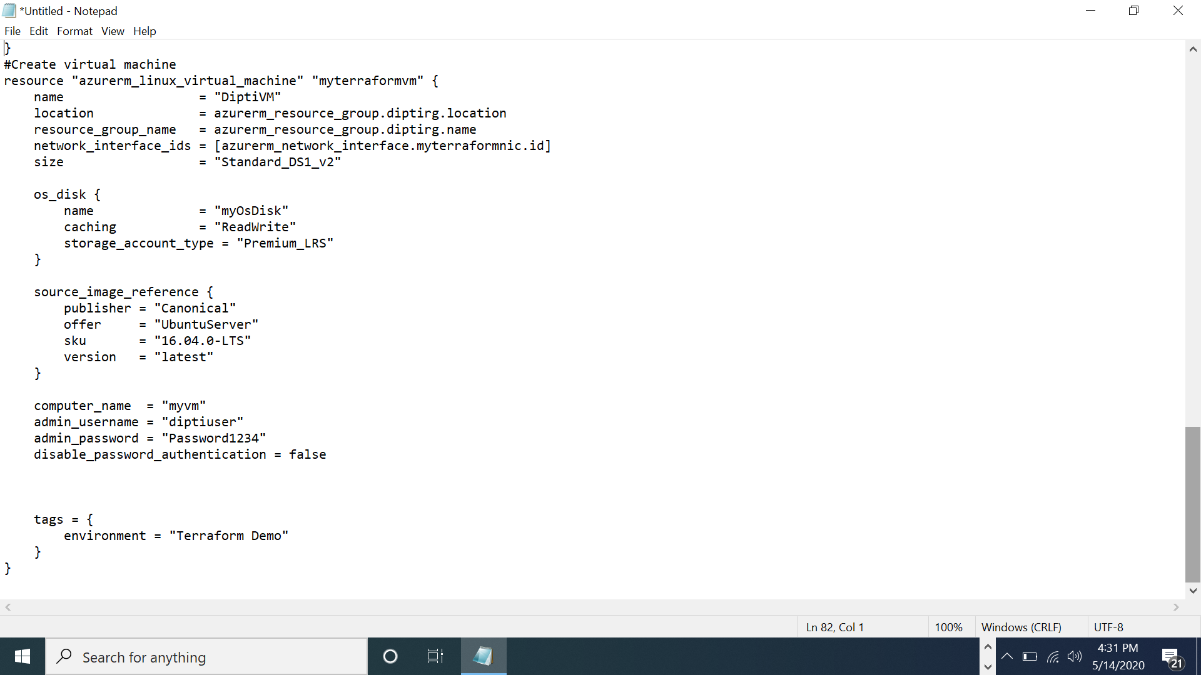

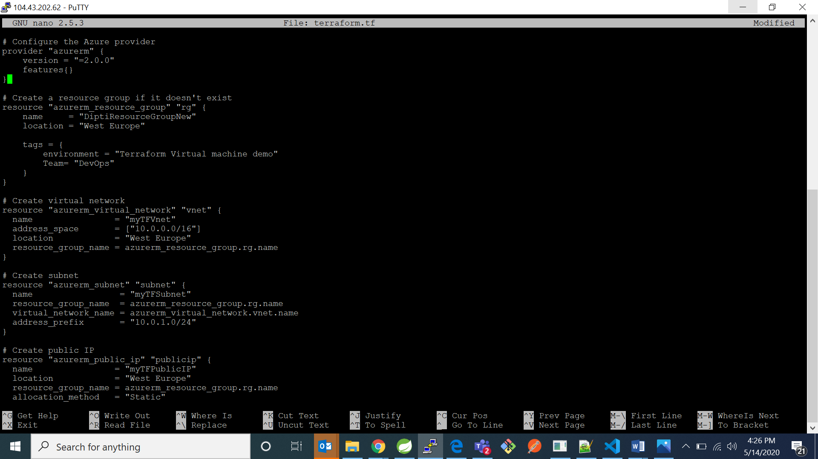

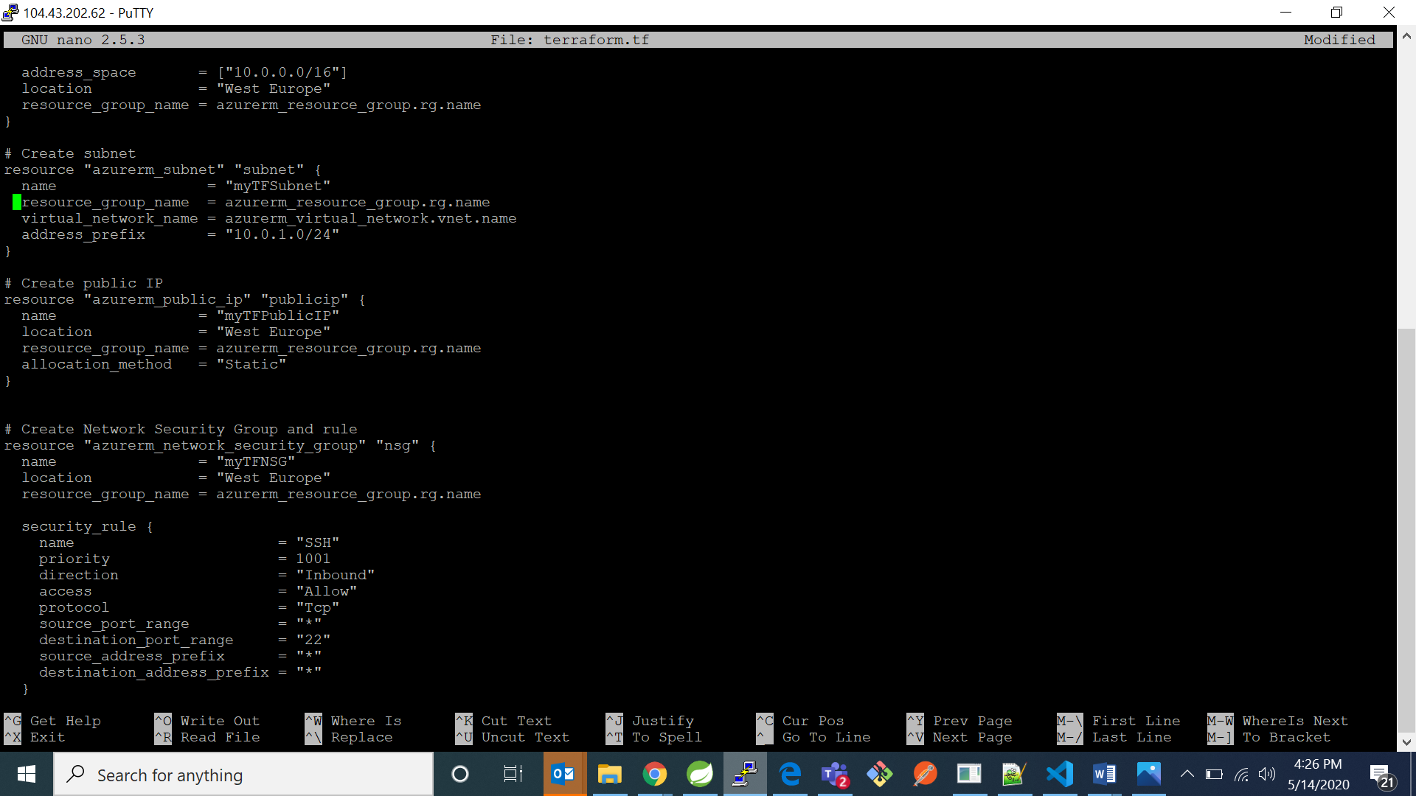

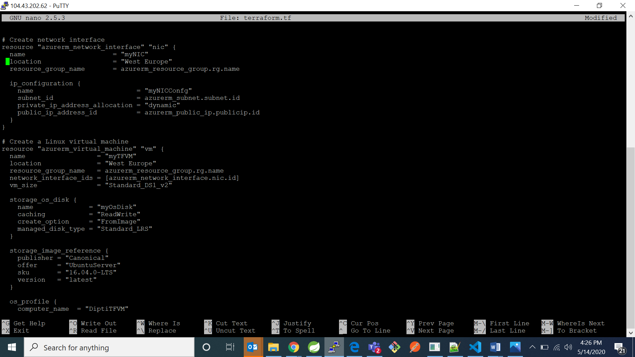

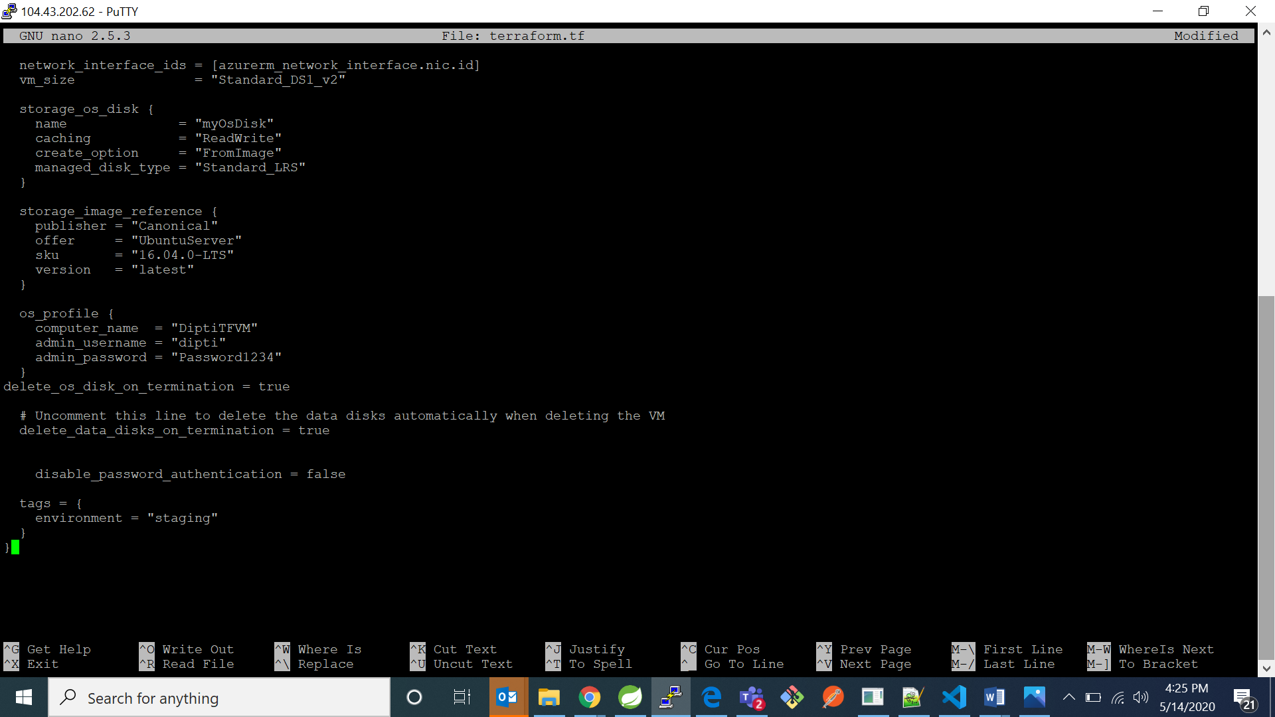

2. Now type command “terraform init”

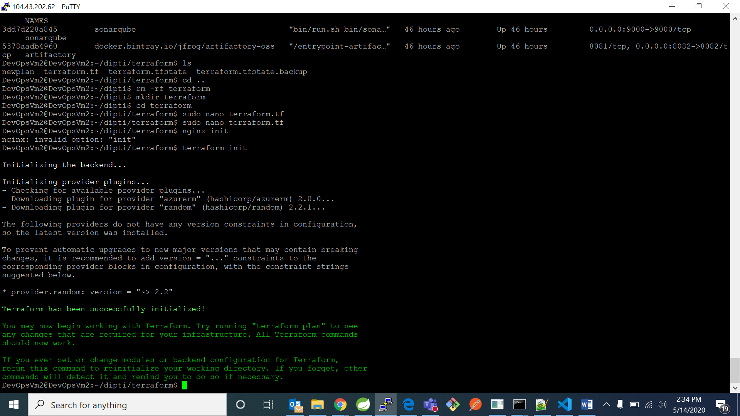

3. Now type terraform plan

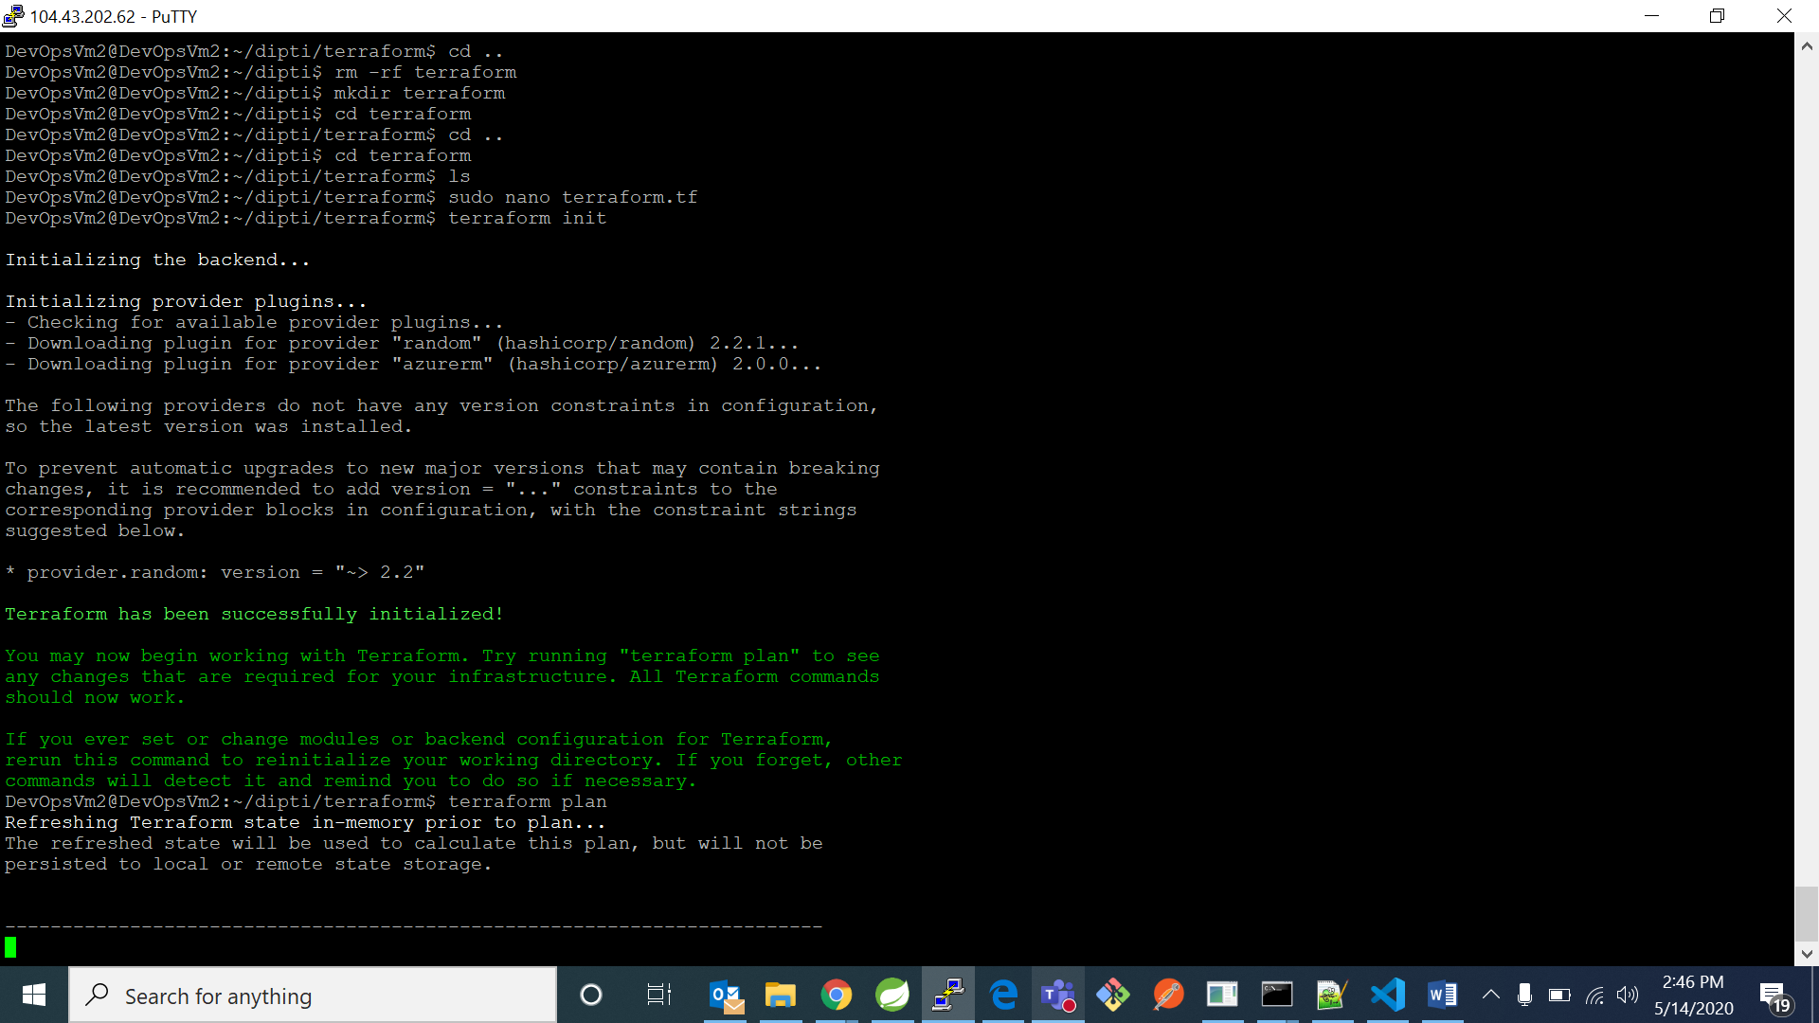

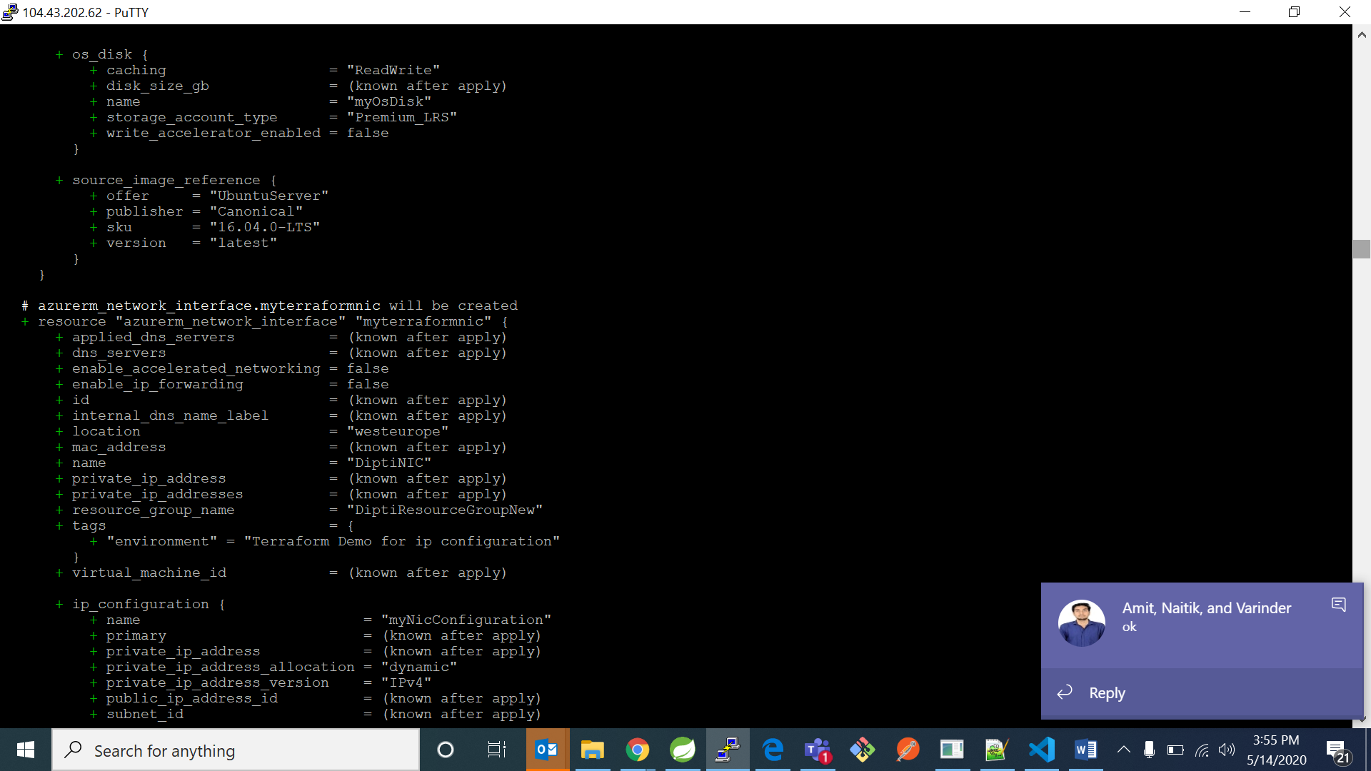

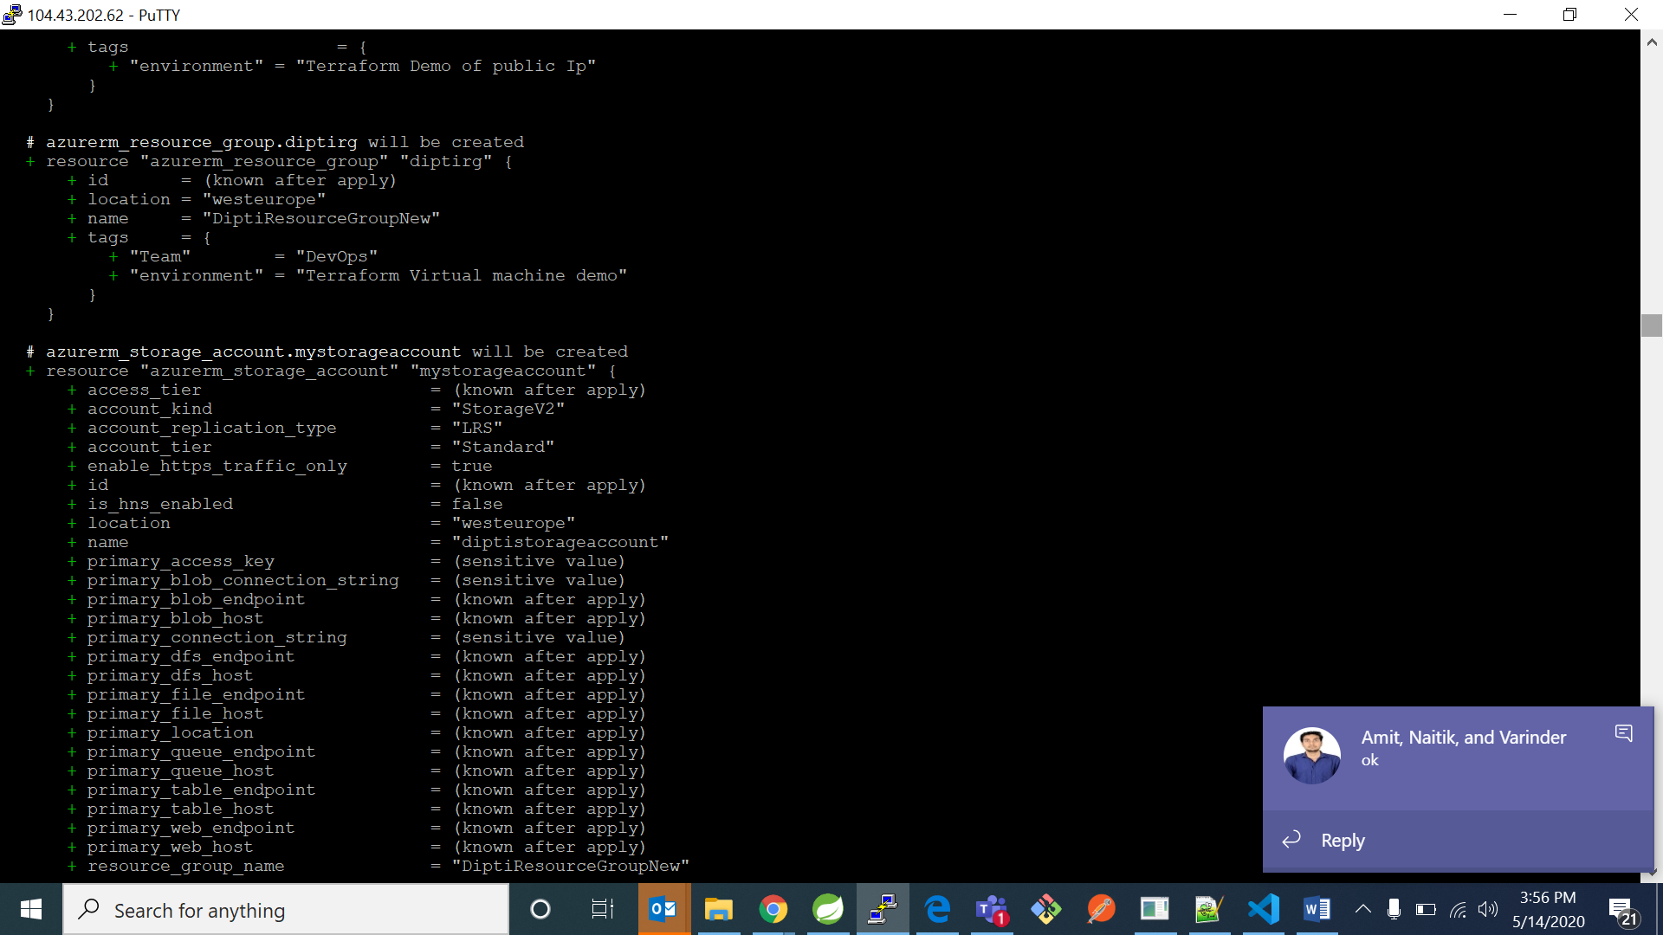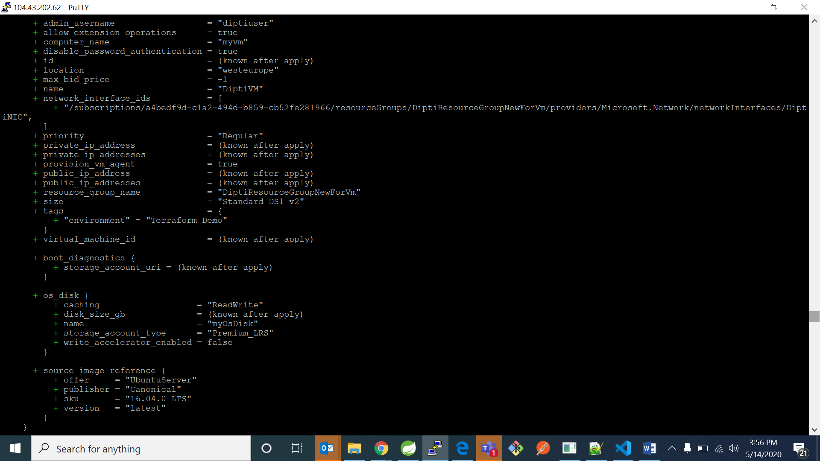

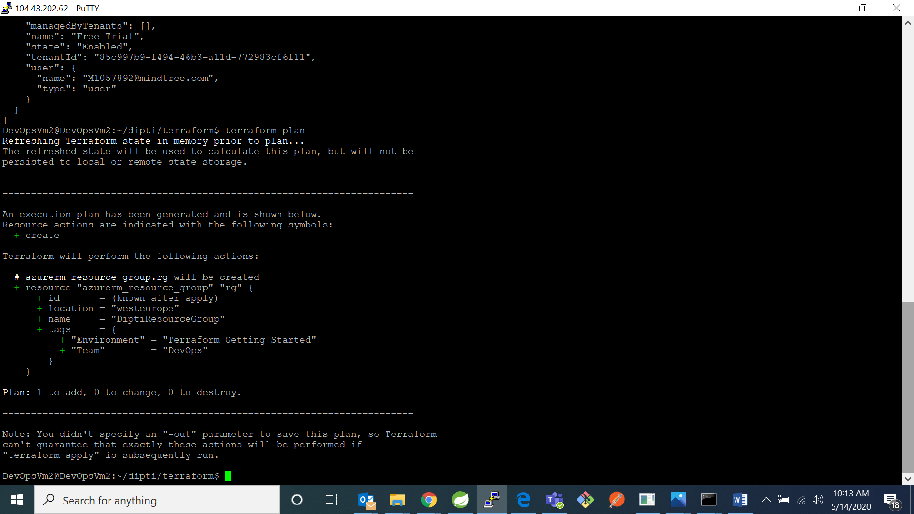

4. Now type command “terraform apply”

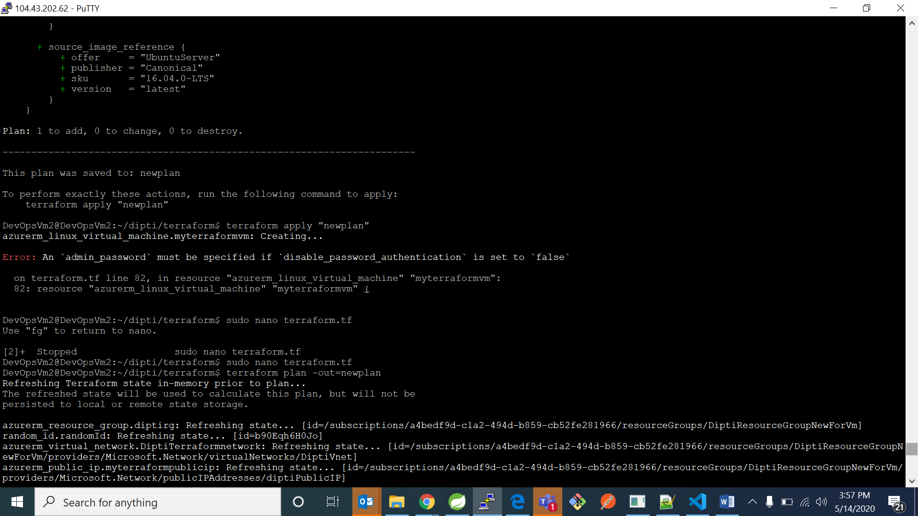

I was getting an error message earlier so in VM creation resource write “disable_password_authentication = false”

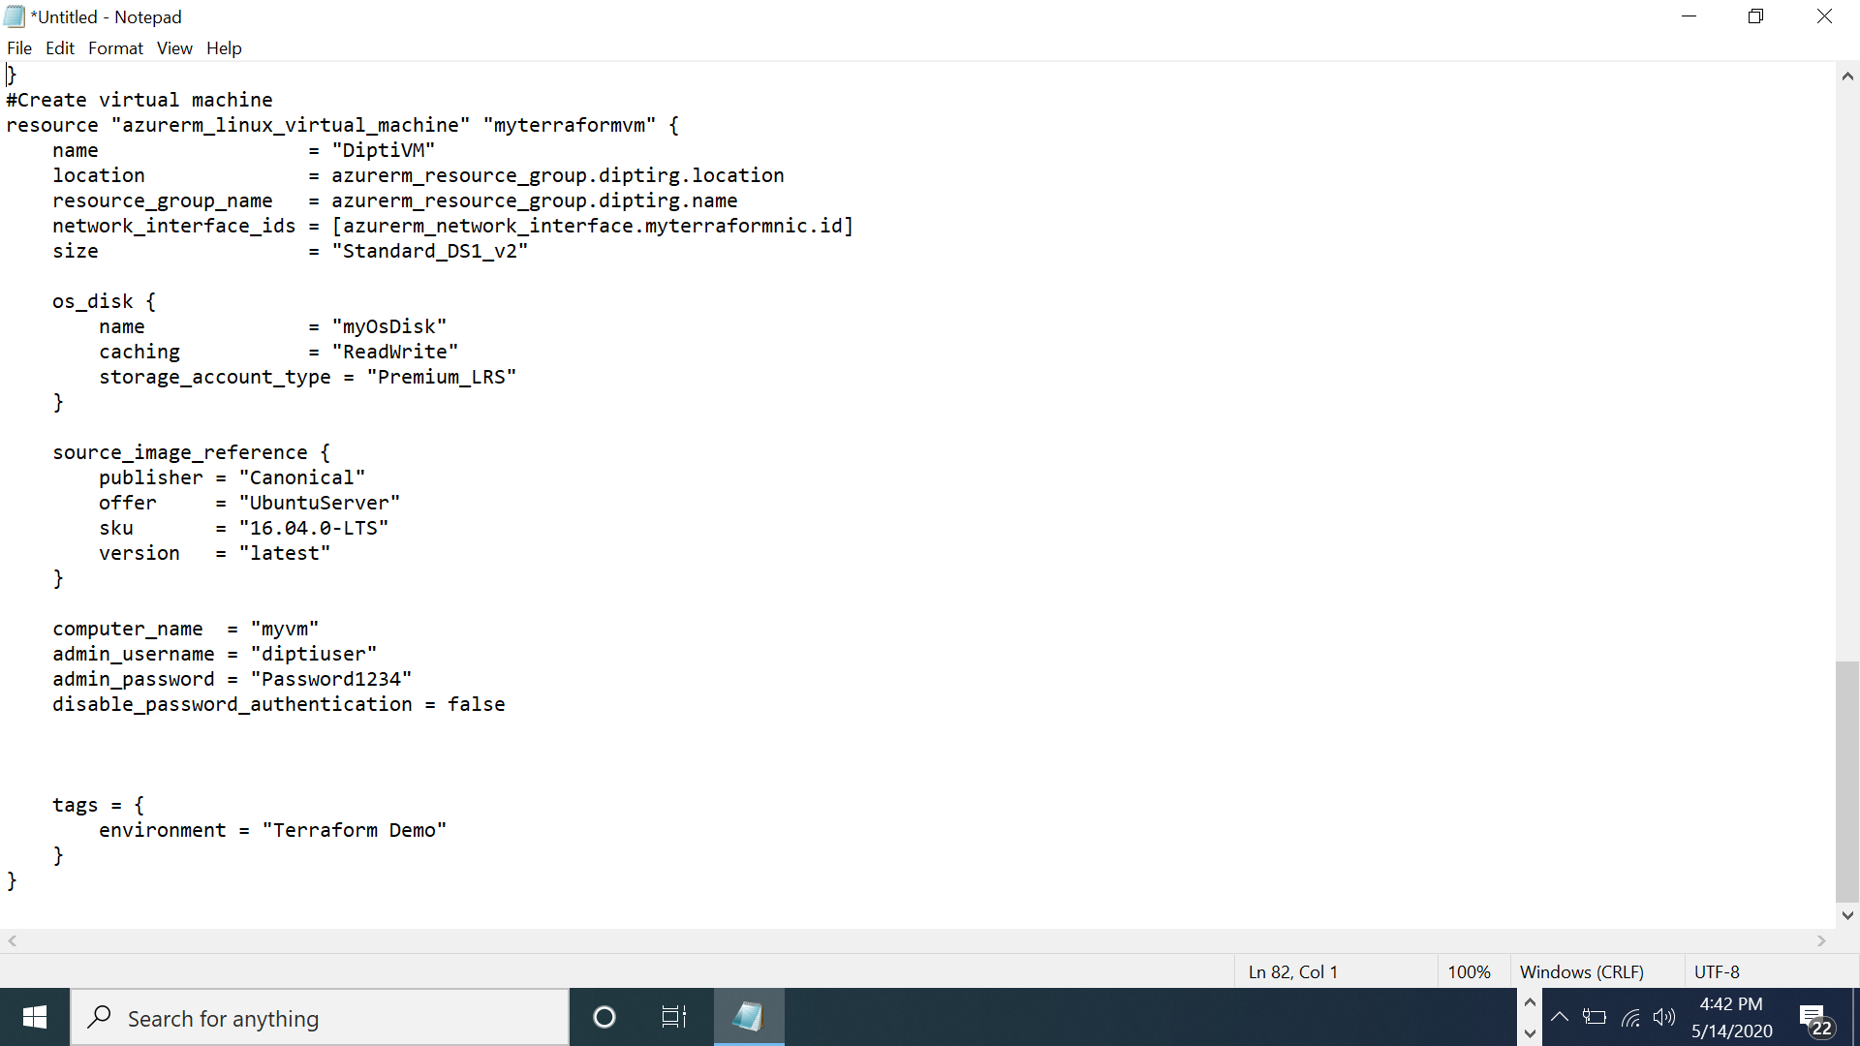

5. Now type command “terraform plan –out=newplan”

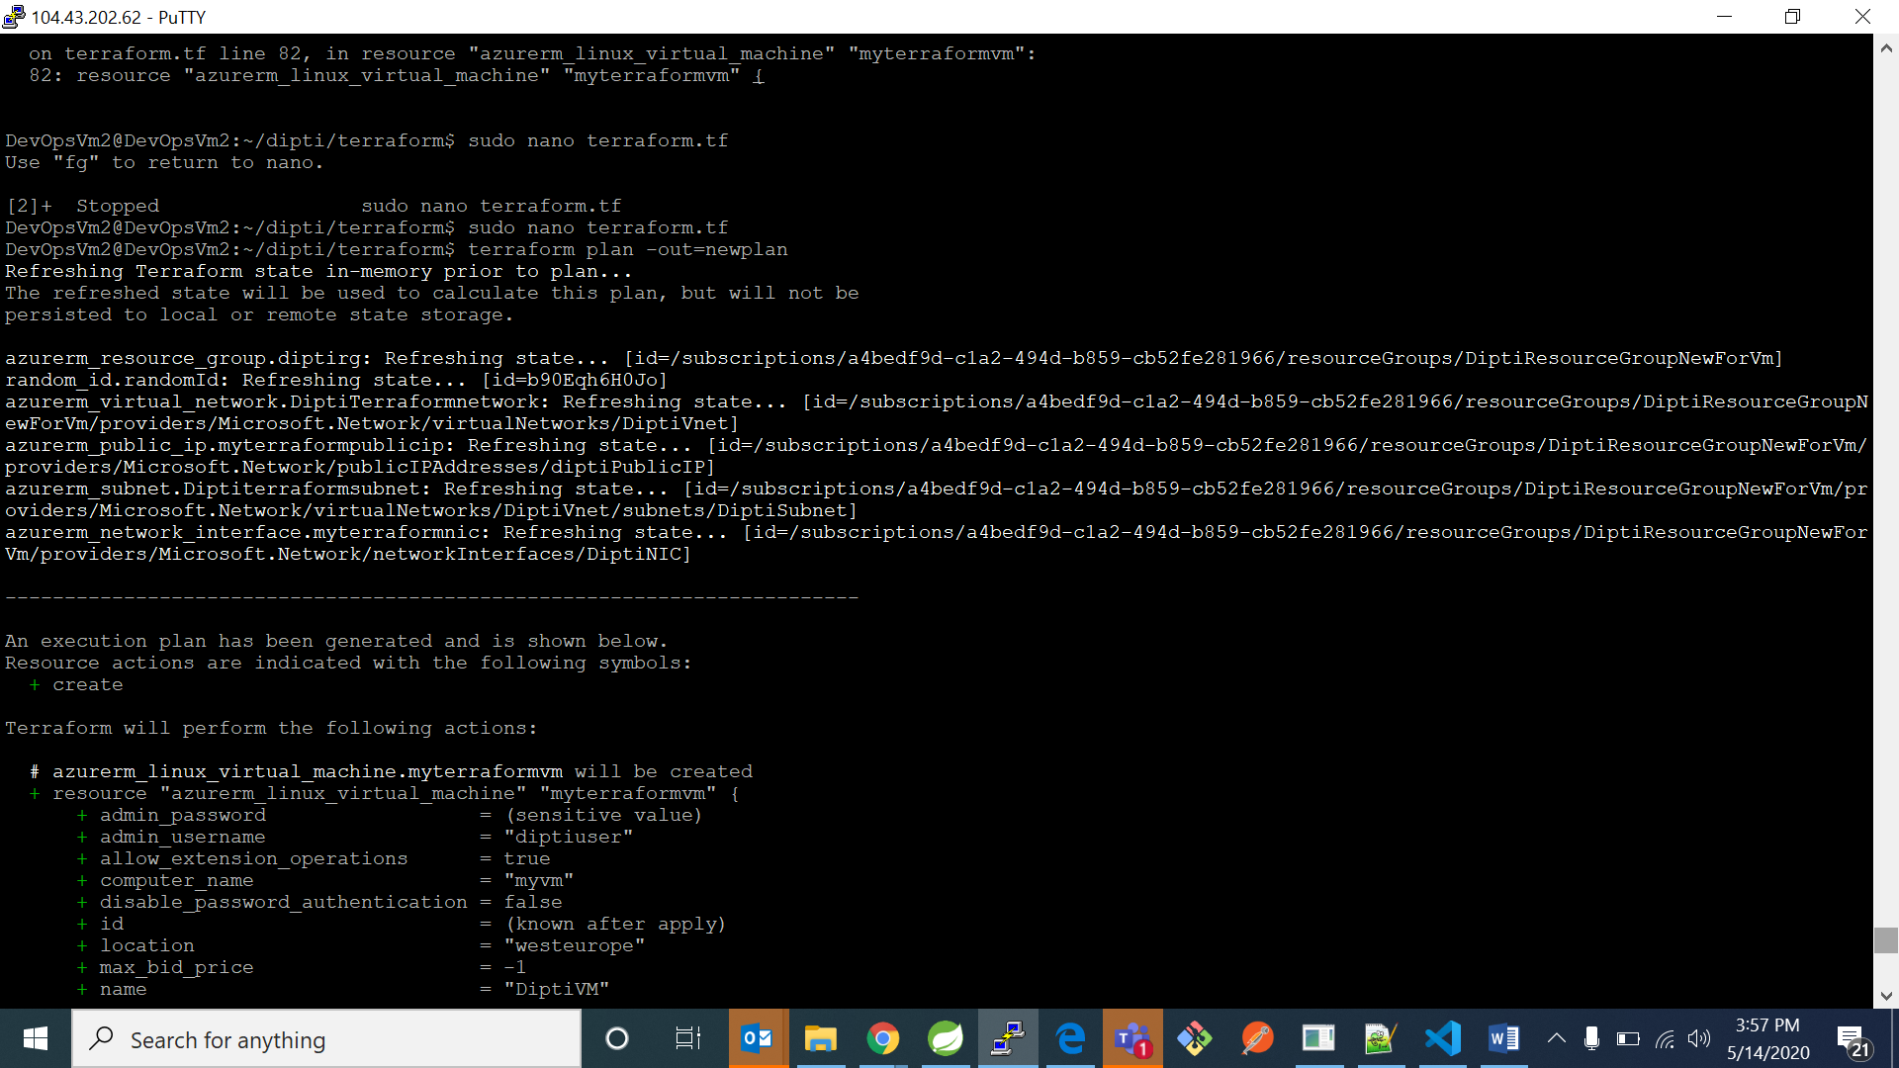

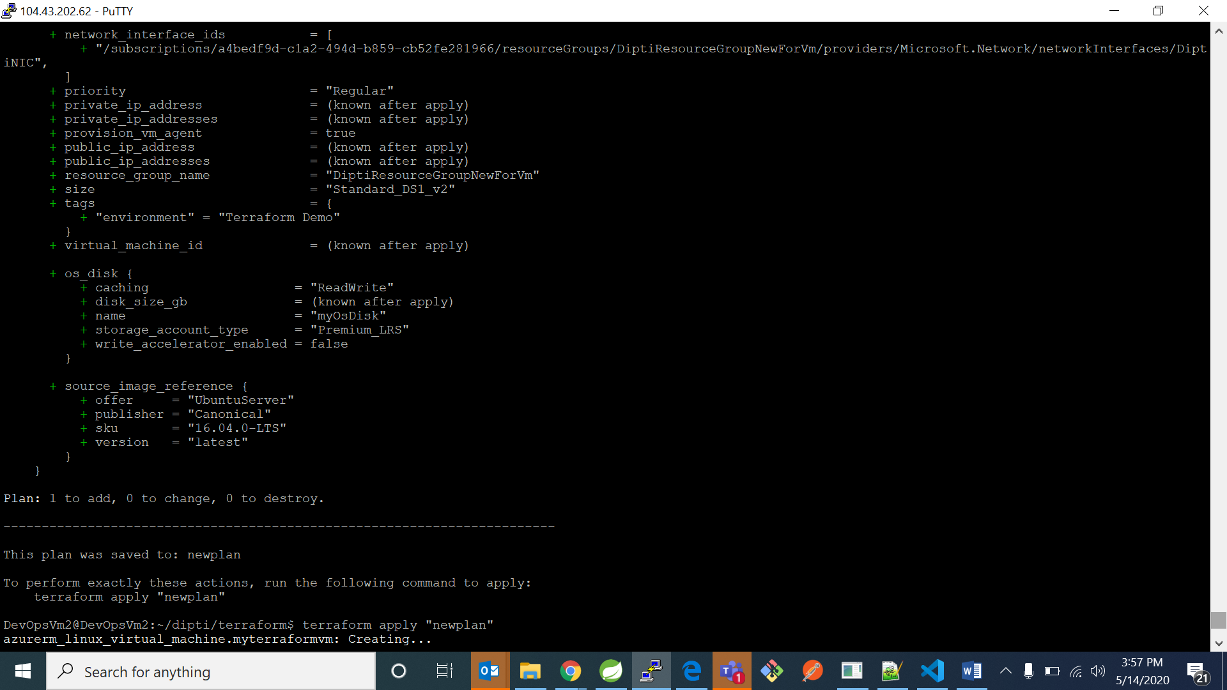

6. Now type command “terraform apply “newplan””





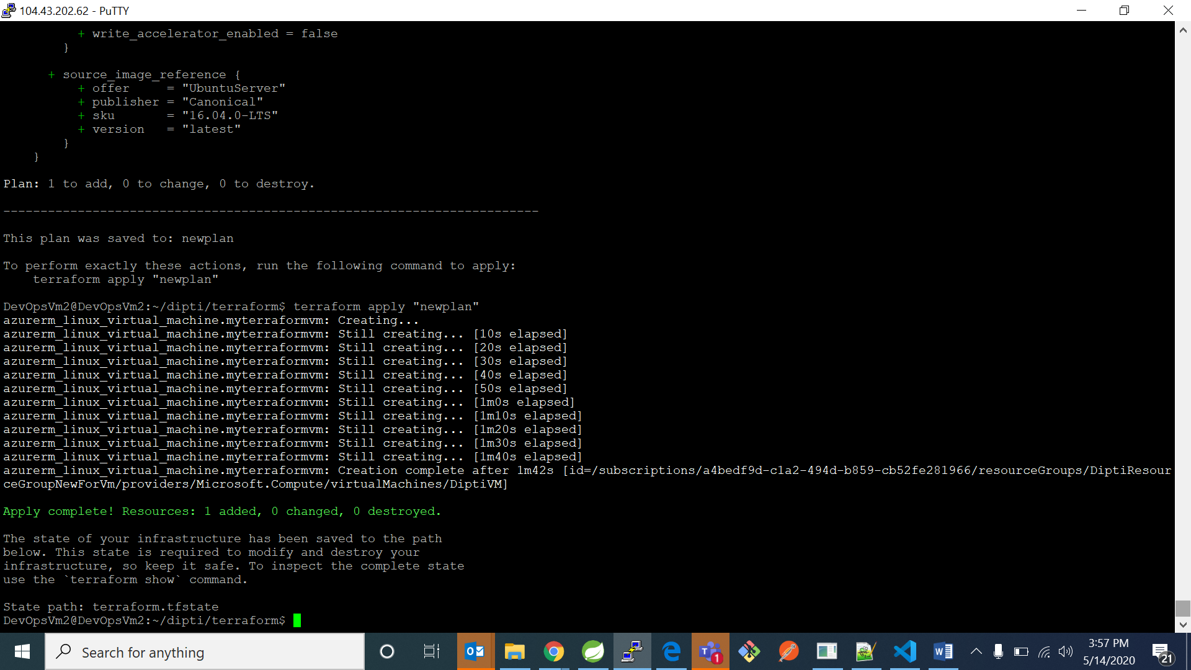

7. Now go to your azure account portal and check for your vm 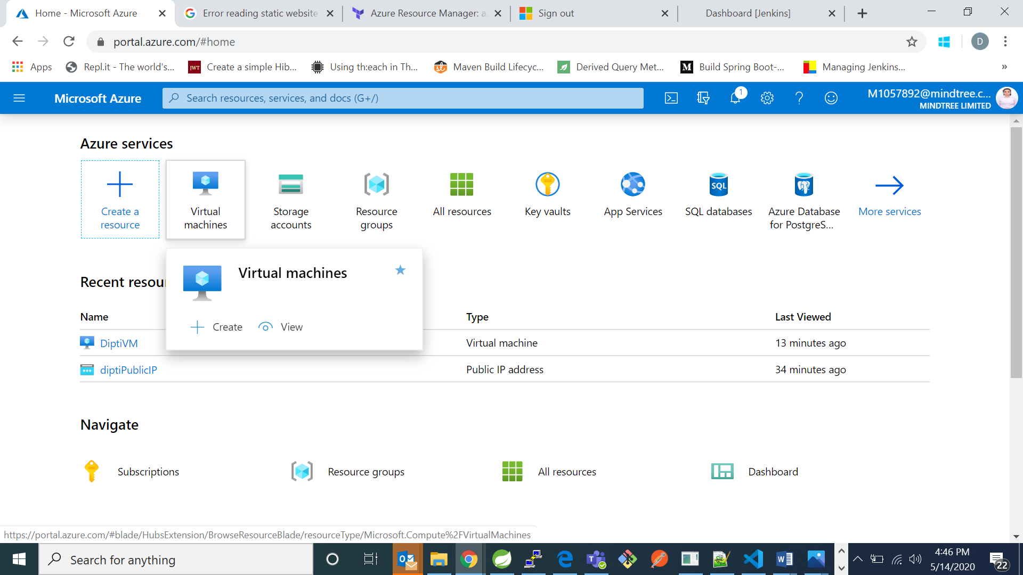

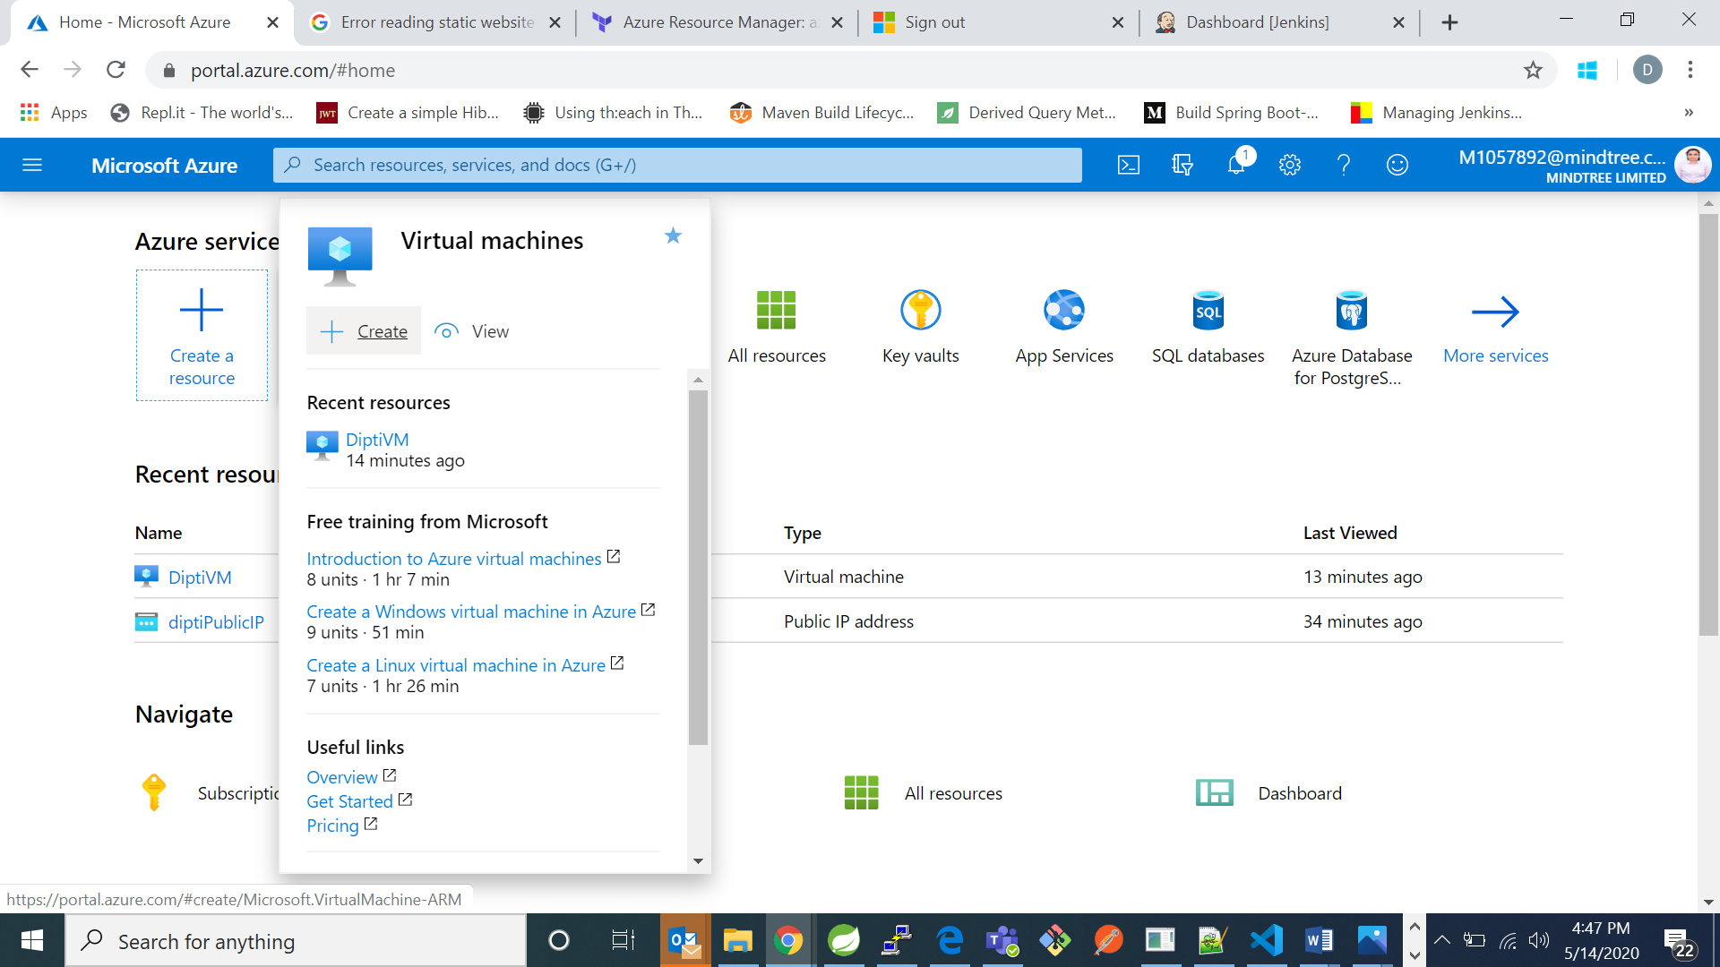

Here I can see my Vm named “DiptiVM” is created successfully.

8. Now go to Virtual machines page and click on your Vm

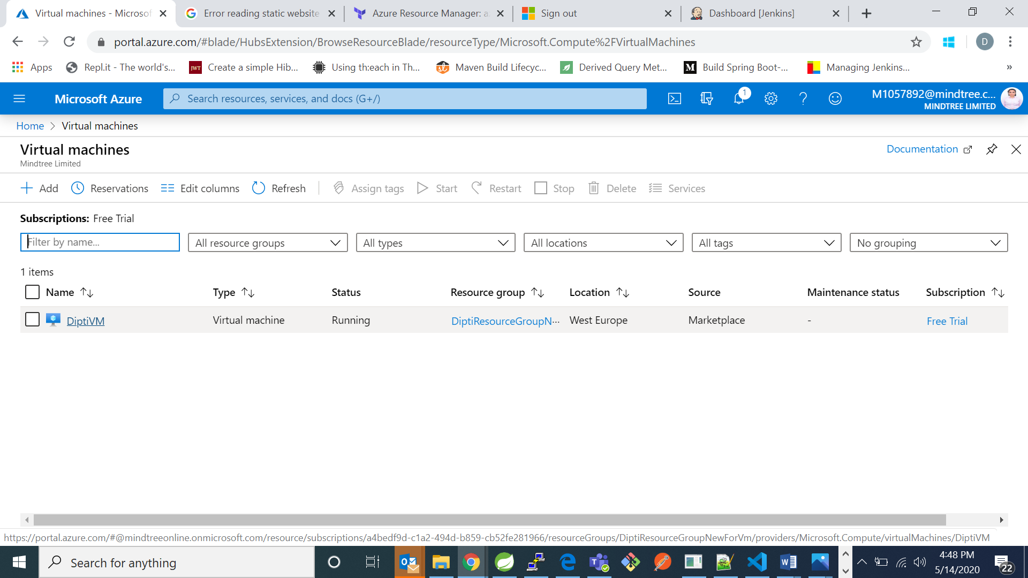

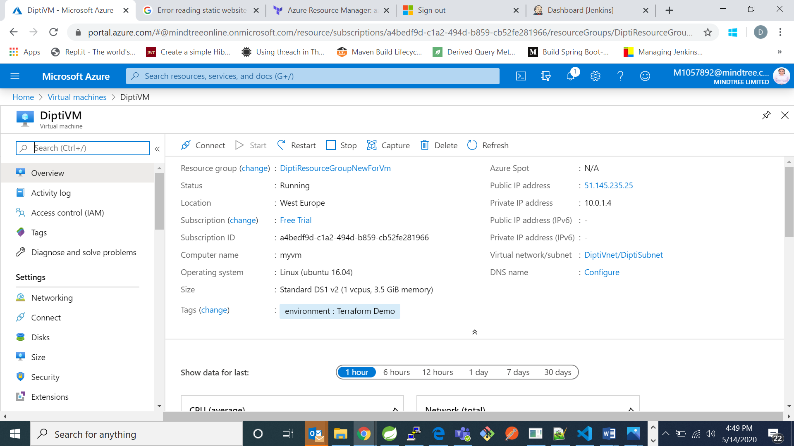

9. From here copy your “Public IP Address” and open putty and paste the IP address. After clicking ok a pop-up will come up just click yes. In my case this operation was already performed.

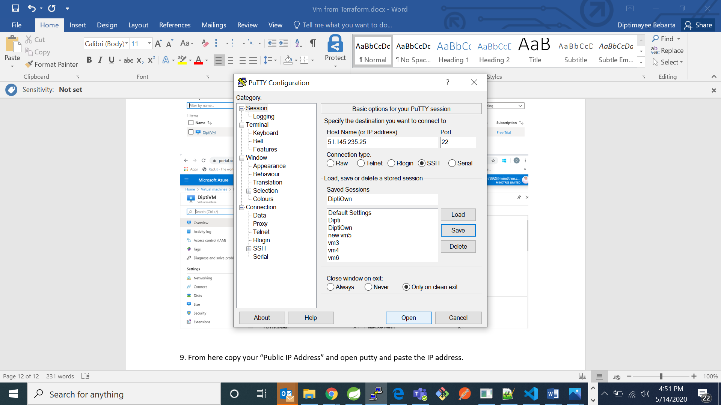

10. Now login as the admin user name you have provided and provide the password written your terraform file.

In my case admin user is “ diptiuser” and the password is “Password1234”

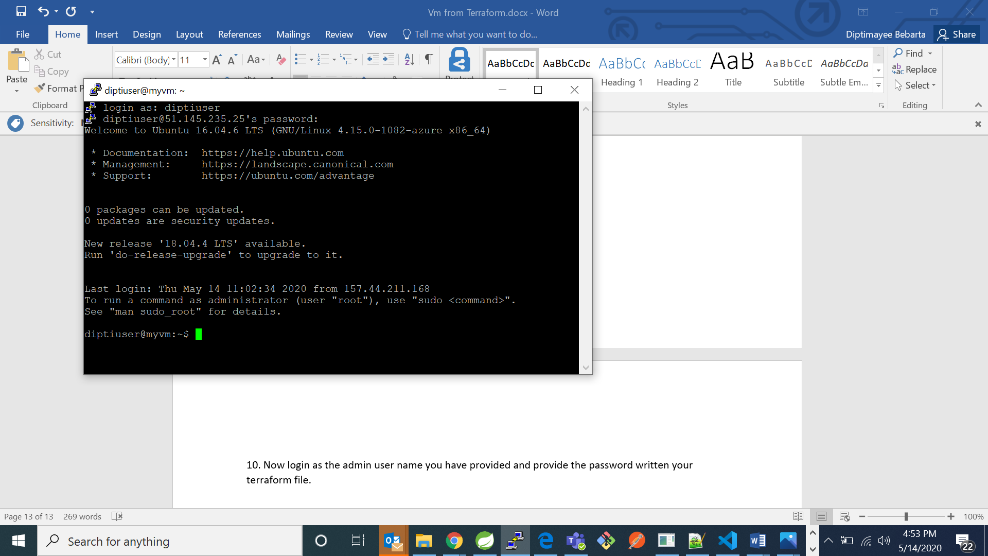

MY VIRTUAL MACHINE WAS SUCCESSFULLY CREATED USING INFRASTRUCTURE AS CODE.